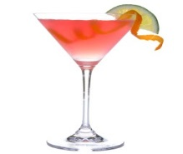2018 Southern NH Trailblazers Annual Banquet

Come join us for a fun evening with a fantastic meal, club awards, door prizes and good times.

**Date:** May 19th

**Location:** Kingston 1686 House Restaurant, Kingston NH

**Time:** 5:30 - 6:30pm, Cocktails (not included in price) and Appetizers

6:30pm - ??, Meal and Dessert

Club Awards and Door Prizes to Follow

**Appetizers:**

Cheese and Cracker Platter

Vegetable and Dip Platter

**Entrée Choices:**

* Chicken Parmesan $24.50
* Baked Haddock $29.65
* 10 oz. Prime Rib $28.37
* 12 oz. Prime Rib $33.53

**Dessert:**

* Brownie Sundae $9.03
* Half size Brownie Sundae $5.16

*Prices include tax and gratuity

Please make checks payable to the Southern NH Trailblazers

All meals are served with baked potato, garden salad, bread and vegetable.

Soda, coffee and tea are also included

Please RSVP by May 12th to Karen Lumnah at 603-583-2322

(Email to: karen.lumnah@mbgre.com)

**Hope to see you there!** 